
Thermodynamics & Kinetics

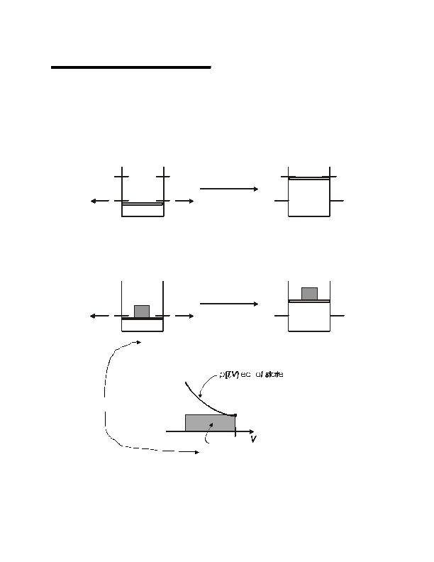

Lecture #3
page 1
Isothermal Gas Expansion

gas (p 1, V 1, T) = gas (p 2, V 2, T)
(∆T = 0)
Irreversibly (many ways possible)
(1)
Set pext = 0
p= 0
T
p= 0

p 1,V1
T
p 2,V2
(2)
Set pext
w(1)

= p2
= − ∫ p dV = 0
V1
ext
v2
p2
T
p2

p 1,V1

w(2)

p

p1
T
p 2,V2
= − ∫ p dV = −p (V −V )
V1
2
2
2
1
v2
p2
V1
-w
(2)
V2
Note, work is negative: system expands against surroundings
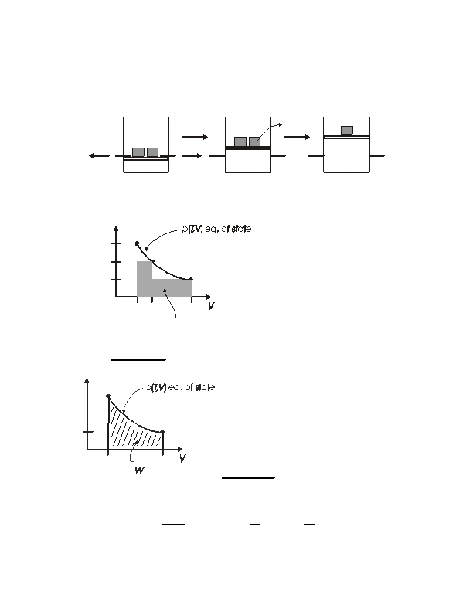
Lecture #3
page 2
(3)
Carry out change in two steps
gas (p 1, V 1, T) = gas (p 3, V 3, T) = gas (p 2, V 2, T)
p1
> p 3 > p2
p2
p3
T
p3

p 1,V
1
T
T
p 3,V
3
p 2,V
2
w(3)
= − V1∫π 3dV − p 2dV = − p 3(V 3 V 1)
∫
V
3
v3
v2
− −p (V −V )
2
2
3
p

p1

p3

p2
More work delivered to
surroundings in this case.
V 1 V3
V2
-w(3)
(4)
Reversible change
p

p1
p = pext throughout

V2
wrev
= − ∫ pdV
V1
p2
V1
-
V2
rev
Maximum work delivered to
surroundings for isothermal gas
expansion is obtained using a
reversible path
For ideal gas:
w
rev
= −
V∫
1
V2
nRT
V
dV = −nRT ln
V
V1
2 = nRT ln
p
2
p1
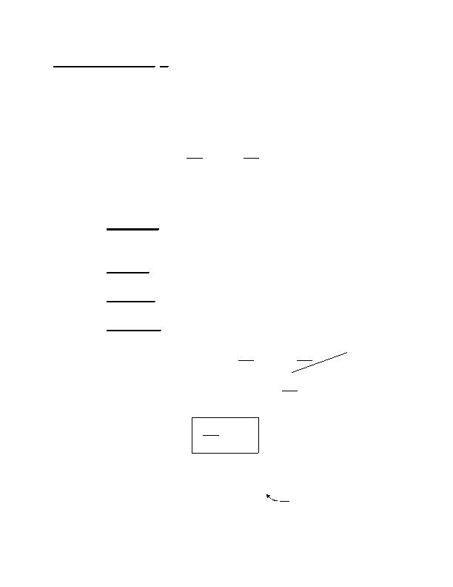
Lecture #3
page 3
The Internal Energy U

dU = -dq + -dw
dU = C path
And U T ,V
(
)
(First Law)
dT − p extdV
⇒ dU = ⎜
⎛ ∂U ⎞
⎝ ∂T
⎟
⎠V
dT + ⎜
⎛ ∂U ⎞
⎝ ∂V
⎟
⎠T
dV
Some frequent constraints:

• Reversible ⇒
dU = - revdq
+ -dwrev
= - revdq
- pdV

(p = p ext )
•

•

•
Isolated

Adiabatic

Constant V
⇒ d-q = -dw = 0

⇒ d-q = 0 ⇒ dU = -dw
⇒ w =
0 ⇒ dU = - Vdq
reversible
=
-pdV
⎛ ∂U ⎞
⎝ ∂T ⎠V

d V-q = ⎜
dU = ⎜

⇒
but also
⎟ dT + ⎜
⎛ ∂U ⎞
⎝ ∂V ⎠T
⎛ ∂U ⎞
Constant V
⎟ dV

⎟ dT
⎝ ∂T ⎠V

very important result!!
d V-q = C dT
V
⇒ ⎜
⎛ ∂U ⎞
⎝ ∂T ⎠
⎟
V
= CV
So
dU = C dT +
V
⎛ ∂U ⎞
⎜
⎝ ∂V
⎟
⎠T
dV
what is this?
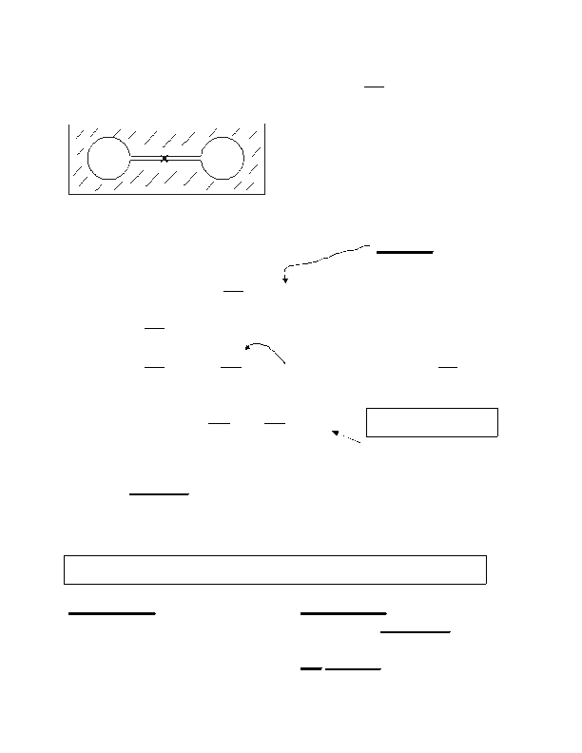
Lecture #3
page 4
Joule Free Expansion of a Gas
(to get
⎛ ∂U ⎞
⎜
⎝ ∂V
⎟
⎠T
)
gas
vac
Adiabatic

Expansion into Vac.
(pext=0)
q = 0

w = 0
gas (p 1, T 1, V 1) = gas (p 2, T 2, V 2)

Since q = w = 0 ⇒ dU or ∆U = 0
Recall
dU = C dT +
V
⎛ ∂U ⎞
⎜
⎝ ∂V
⎛ ∂U ⎞
⎟
⎠T
⎜
⎝ ∂V
⎟
⎠T
⎛ ∂U ⎞
⎜
⎝ ∂V
⎟
⎠T
dV = 0
Constant U
dV U = −C VdTU
= − V ⎜Χ
⎛ ∂T ⎞
⎝ ∂V
⎟
⎠U

⎛
= ⎜
measure in Joule exp't!
⎛ ∆T ⎞
⎜ ⎟
⎝ ∆V ⎠U
Joule did this.
lim
∆V →0
⎛
⎜
∆T ⎞
⎝ ∆V
⎟
⎠U
∂T ⎞
⎝ ∂V
⎟
⎠U
≡ ηJ
∴ dU = C VdT −C η dV
V J
•
For Ideal gas
⇒
ηJ
= 0
dU =C VdT
U(T)
Joule coefficient

exactly
Always for ideal gas
only depends on T
The internal energy of an ideal gas depends only on temperature
Consequences ⇒ ∆U = 0
For all isothermal expansions or
compressions of ideal gases

For any ideal gas change in state
⇒
∆U = ∫C dT
V

